Summary of supports for:___________________
Child’s photo
DOB:
Interests:
Favourite books: Favourite songs:
Strengths:
Safety

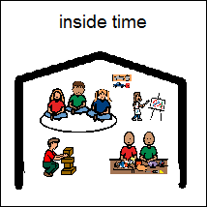

Educator who is supporting the child wears lanyard with relevant visuals attached
Preferred social and learning experiences
Routines/Eating/Toileting/Sleeping

